1. **DIGITAL DESIGN USING HDL LABORATORY (UE18EC206)**
2. **EXPERIMENT-11**
3. **SIMULATION OF MEALY AND MOORE MODELS USING XILINX VIVADO TOOL**

**Aim:** Write a verilog code to simulate Mealy and Moore machine Sequence detector for

the given sequence

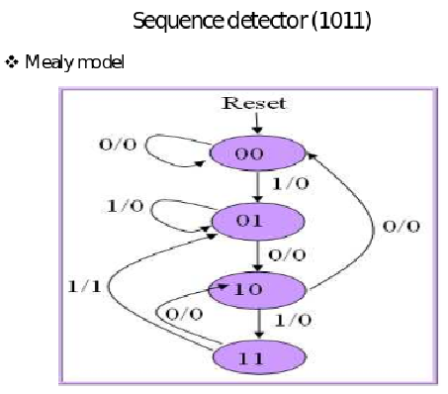

**module** mealy_1011( input clk, reset, inp, output outp);

**reg** outp;

**reg** [1:0] state;

**reg** [1:0] next_state;

**always @(posedge clk)**

begin

if (reset)

state <= 2'b00;

else

**state <= next_state;**

end

**always** @**(state, inp)**

**case**( state )

**2'b00**: **begin**

**if**( inp )

**begin**

next_state <= 2'b01;

outp <= 0;

**end**

**else**

**begin**

next_state <= 2'b00;

outp <= 0;

**end**

**end**

**2'b01: begin**

**if**( inp )

**begin**

next_state <= 2'b01;

outp <= 0;

**end**

**else**

**begin**

next_state <= 2'b10;

outp <= 0;

**end**

**end**

**2'b10**: begin

if( inp )

begin

next_state <= 2'b11;

outp <= 0;

end

else

begin

next_state <= 2'b00;

outp <= 0;

end

end

**2'b11**: begin

if( inp )

begin

next_state <= 2'b01;

outp <= 1;

end

else

begin

next_state <= 2'b10;

outp <= 0;

end

end

endmodule

**Moore:**

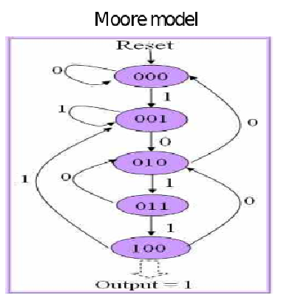

**module** moore_1011( input clk, reset, inp, output outp);

**reg** outp;

**reg** [2:0] state;

**reg** [2:0] next_state;

**always @(posedge clk)**

begin

if (reset)

state <= 3b000;

else

**state = next_state;**

end

**always** @**(state, inp)**

**case**( state )

**3'b000**: **begin**

**if**( inp )

next_state <= 3'b001;

**else**

next_state <= 3'b000;

**end**

**3'b001: begin**

**if**( inp )

**ne**xt_state <= 3'b001;

**else**

next_state <= 3'b010;

**end**

**3'b010**: begin

if( inp )

next_state <= 3'b011;

else

next_state <= 3'b000;

end

3**'b011**: begin

if( inp )

next_state <= 3'b100;

else

next_state <= 3'b010;

end

3**'b100**: begin

if( inp )

next_state <= 3'b001;

else

next_state <= 3'b010;

end

endcase

**always @ (state or reset)**

begin

if (reset)

outp = 0;

else

case(state)

3’b000: outp = 0;

3’b001: outp = 0;

3’b010: outp = 0;

3’b011: outp = 0;

3’b100: outp = 1;

endcase

end

endmodule

**Testbench:**

module mealy_1011_tb();

reg clk,reset,inp;

wire outp;

mealy_1011 uut(clk,reset,inp,outp);

initial

begin

clk=0; reset=0; inp=0;

#10 reset=1;

#15 reset=0;

#15 inp=1;

#15 inp=0;

#10 inp=1;

#10 inp=1;

#15 inp=1;

#15 inp=0;

#10 inp=1;

#10 inp=1;

#10 inp=0;

end

always #5 clk=~clk;

endmodule